**Employee Management System**

**A Project Work Report**

*Submitted in the partial fulfilment for the award of the degree of*

**BACHELOROF** E**NGINEERING**

**IN**

**BIG DATA ANALYTICS**

Submitted by:

**Iktaj Singh Bhinder**

**Ashish Kumar**

**Sougata Chanda**

**Vaibhav**

**University Roll Number**

**19BCS3843(Iktaj)**

**19BCS3833(Ashish)**

**19BCS3832(Sougata)**

**19BCS3835(Vaibhav)**

**Under the Supervision of:**

Ms. Jyoti Mehra

**CHANDIGARHUNIVERSITY,GHARUAN,MOHALI-140413,PUNJAB**

**December, 2020**

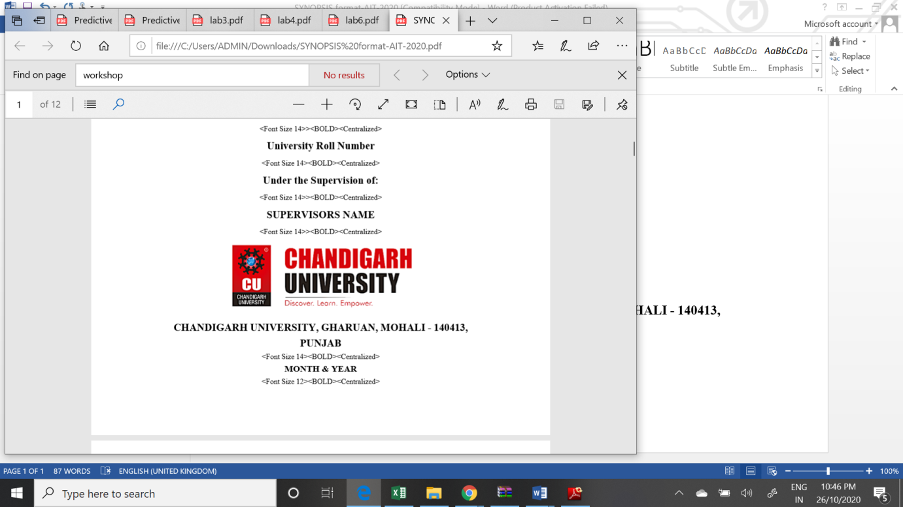

# 

# PROJECT COMPLETION CERTIFICATE

## Project Title

This is to certify that **Iktaj Singh Bhinder** has successfully completed the project work titled “**Employee Management System”** *Submitted in the partial fulfilment for the award of the degree of* **BACHELOR OF** E**NGINEERING IN BIG DATA ANALYTICS**

This project is the record of authentic work carried out during the academic year

**Ms. Jyoti Mehra**

Project Guide

**Date:**

# DECLARATION

I the undersigned solemnly declare that the project report is based on my own work carried out during the course of our study under the supervision of **Ms. Jyoti Mehra**. I assert the statements made and conclusions drawn are an outcome of my work. I further certify that the work contained in the report is original and has been done by me under the general supervision of my supervisor.

II. The work has not been submitted to any other Institution for any other degree/diploma/certificate in this university or any other University of India or abroad.

III. We have followed the guidelines provided by the university in writing the report.

IV. Whenever we have used materials (data, theoretical analysis, and text) from other sources, we have given due credit to them in the text of the report and giving their details in the references.

**Name**

Iktaj Singh Bhinder

**UID:**

19BCS3843

# ACKNOWLEDGEMENT

I have taken efforts in this project. However, it would not have been possible without the kind support and help of many individuals and organizations. I would like to extend my sincere thanks to all of them.

I am highly indebted to (Name of your Organization Guide) for their guidance and constant supervision as well as for providing necessary information regarding the project & also for their support in completing the project.

I would like to express my gratitude towards my parents and my department for their kind co-operation and encouragement which help me in completion of this project.

THANKS AGAIN TO ALL WHO HELPED

**Abstract**

This report includes a development presentation of an information system for managing the staff data within a small company or organization. The system as such as it has been developed is called Employee Management System. It consists of functionally related GUI (application program) and database.

This system consists of an application program, on one hand, and a database (repository of data) on the other. The program performs the basic operations upon the database as retrieving, inserting, updating and deleting data.

Any additional functionality is a goal of a further module development.

It is a kind of strategy to start the development from designing and constructing the database, as this structure will determine the further structure of the application program.  flexible and easy to use Employee

Management software solution for small and medium sized companies provides modules for personnel information management thereby organization and companies are able to manage the crucial organization asset- employees

**Chapter 1:**

**Introduction to project**

**Employee Management System**

An employee management system is a platform wherein all the work-related as well as important professional and personal details of all employees is stored and ,managed and can be displayed and modified in a safe and secure way. The admins of the Employee you can manage admin activities in an easier and quicker way.

Employees are the pillar of any organization and an ideal employee management tool makes a big difference to an organization.

Java is a platform independent language. Its created applications can be used on a standalone machine as well as on distributed network. More over applications developed in java can be extended to Internet based applications.

Thus java was chosen as background to design this application.

The logical database model (tables, their content and the relationships between them) respond to the given task and cover the basic requirements. The Interface of the program is user-friendly, and the program is easy for use as it is possible. Both controls and forms should logically and functionally be related within the program and fully respond to the structure of the database. Exception-handling is also taken into an account during the system’s development due to eventual exceptions that may occur.

**Chapter 2**

**Project Profiles and Requirements**

1. **Project Partners:**

* Strength: 4
* Name:

Iktaj Singh Bhinder(19BCS3843)

Ashish Kumar(19BCS3833)

Sougata Chanda(19BCS3832

Vaibhav(19BCS3835)

1. **Hardware / Software Environment:**

Hardware:

* Intel Pentium IV or above
* 250M.B.of Hard Disk Drive (Free space Memory)
* 256 M.B. of R.A.M.

Software:

* Operating System: Windows 7 or above

Mac OS X or above

Linux

1. **Development Tools:**

* Front End: Java Swing, Java AWT (Eclipse 2017 VERSION or above)
* Back End: Java, MySQL (Eclipse, Xampp Apache server)

**Chapter 3**

**Implementation Details**

**Introduction**

This chapter gives a brief theoretical preview upon the database information systems and goes through the essence of the problem that should be resolved.

**3.1 Background**

Most of the contemporary Information systems are based on the Database technology as a collection of logically related data, and DBMS as a software system allowing the users to define, create, maintain and control access to the database. The process of constructing such kind of systems is not so simple. It involves a mutual development of application program and database. The application program is actually the bridge between the users and the database, where the data is stored. The basic idea can be depicted on Figure 1.1 below

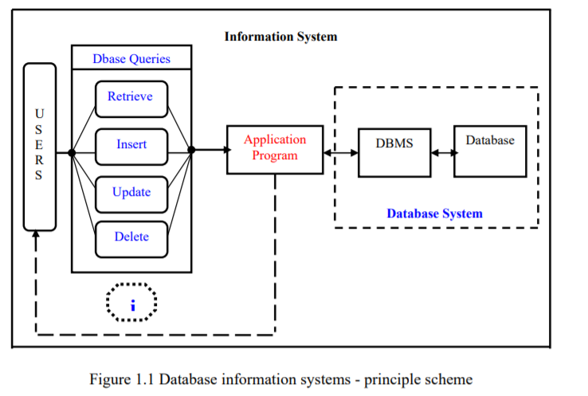

Thus, the well-developed application program and database are very important for the reliability, flexibility and functionality of the system. The so defined systems differentiate to each other and their development comprises a great variety of tasks to be resolved and implemented.

**3.2 . Method**

At the very commencement, I proceeded to a decision to carry out the development of my task into the following steps:

1. Exploring the available development environments and techniques.

2. Database Analyzing.

3. Database design and Implementation.

4. Program’s Structure Analyzing.

5. GUI (Graphical User Interface) constructing.

6. Bringing all the stuff together (controls data binding and functions

implementation).

7. Tests.

Each one of these steps could be explained in some brief details as follows:

1**. Exploring the available development environments and techniques**

There is a lot of programming environments available to be used for such kind of

elaborations. The point is to choose such an environment that we will be able to operate

with in a convenient and easy way. This is more or less optional and individual process,

that depends on the developer’s experience as well.

**2. Database Analyzing**

It concerns all of the demands, put upon the database content and its functionality.

The database should be designed and implemented in a way that the user would expect

it to be.

**3. Database design and Implementation**

This step is tightly related with the previous one as it is completely determined by

the requirements, analyzed and discussed in step2.

**4. Program’s Structure Analyzing**

The application program as an interface between the users and the database should

be an accurate “reflection” of the database on the screen; hence a well analyzed and

defined structure is needed.

**5. GUI Construction**

After analyzing the program’s structure and defining what it should consist of, a

graphical representation of this stuff is needed in order to enable the user to interact

with the data.

**6. Bringing all the stuff together**

The next step that should be taken is connecting the program with the database and

performing the necessary functionality upon all of the controls.

**7. Tests**

To ensure that everything works properly and as it has been expected, test

performance has to be done upon the system’s functionality.

**Chapter 4**

**Database Analyzing, design and implementation**

The database for the system should include information of company’s staff,

respectively of its employees. The data is subdivided into the following groups:

**Employees’ Basic Details**

Employee_ID_Number

Name

DOB

Mobile number

City

Postal_Code

**Working History**

Qualification

Current_Experience

Joining_Date

Project

Gender

**Time_Information**

Company phone

Calendar

Days_off

Over_Time

**Salary Information**

Monthly_Salary

monthly_Taxes

monthly_Deductions

**Chapter 5**

**Program’s Structure Analyzing and GUI Constructing**

After getting the database prepared, application program should be constructed and

implemented in some programming environment to enable the users to communicate with the database.

Graphical User Interface (GUI) is intended to be built up as a basic structure of the

program.

The first general advice when constructing GUIs is to “know thy users” as there is a large number of rules and requirements, concerning the whole process of GUI development.

Every GUI consists of certain number of controls (text-boxes, comboboxes, buttons…etc.). The list of all properties and methods for all controls is called Application Programming Interface (API).

A set of controls is used in order to reach the desired purpose, what concerns the functionality of the application, including Labels, Text boxes, Combo Boxes, Data Grid, Buttons, Group Boxes, Panels, Tab controls etc.

All of these controls, available in the program, are fitted to the corresponding forms that are used in the application.

The Program contains two basic forms:

* General - used as a platform
* And a second that is loaded onto the first (General) form.

One control that is heavily used is **the Label** control. It is used to display text on the form.

A Label-control is declared as: • Private Label label_name;

And afterwards - instantiated by the initComponent method:

• Label_name = new Label();

-For all controls, the default constructor is used as their properties are set after that. **The role of the Label is to point at the responding text field, showing what it is intended to be used for.**

Chapter 4: Output Analysis (screenshots)

**5.1 Retrieving data from the database**

Retrieving data from a database is less or more tightly related to dealing with the SELECT query that should be applied to the database in order to extract the desirable result, which one should satisfy certain conditions.

This SQL query has the following structure:

SLECT FROM WHERE [(condition_1), (condition_2), …..(condition_n)].

Into the WHERE-statement, the following logical and arithmetical operators are included as well: [AND, OR, <=, >, >=, =].

It sets some of the functionality properties of some of the other buttons, logically related to the eventual operations that may be performed upon the retrieved data and calls a function that establishes a connection to the database and performs the desirable SQL query upon it.

**5.2 Saving data into the database**

This kind of operation upon the database is subdivided into two groups:

* Saving a new employee’s records (Populating all of the tables with data)
* Add a record to an employee’s data records.

**Saving new employee’s records**:

The whole process comprises a few actions, but not all of them are compulsory to be accomplished at once. First of all, to unlock the fields in order to get them prepared for accepting new data, the (“Add Employee”) button has to be clicked. Afterwards, we can go to the desired form and fill the required data in. When data is saved into the parent table, we have the primary key, which one is the Employee_ID_Number, but this value is also needed for proceeding to other tables.

**5.3 Updating records into the database**

This operation, performed upon a database, updates the info of an existing record. One thing should always be taken into an account when we deal with records-updating: **We need to know the primary key’s value of the current record** that we would like to get updated by the system, as in other way a rather different record would be updated.

**5.4 Deleting data from the database**

Deleting a single Employee record from the database means moving to a certain child table, selecting the record we want to be deleted and press the “Delete Employee” button. The result is instantly reflected into the database and back into the program as well. There is a bit difference between performing single record deletion into the child tables and performing a delete operation upon the whole amount of records of an employee.

**Chapter 6**

**Output Analysis (screenshots)**